CISC Processor

MOTOROLA 68000
Introduction
The Motorola 68000 ("'sixty-eight-thousand'"; also called the m68k or Motorola 68k, "sixty-eight-kay") is a 16/32-bit CISC microprocessor, which implements a 32-bit instruction set, with 32-bit registers and 32-bit internal data bus, but with a 16-bit main ALU and a 16-bit external data bus,[1] designed and marketed by Motorola Semiconductor Products Sector (later Freescale Semiconductor, now NXP). Introduced in 1979 with HMOS technology as the first member of the successful 32-bit m68k family of microprocessors, it is generally software forward-compatible with the rest of the line despite being limited to a 16-bit wide external bus.[2] After 38 years in production, the 68000 architecture is still in use.
Block Diagram
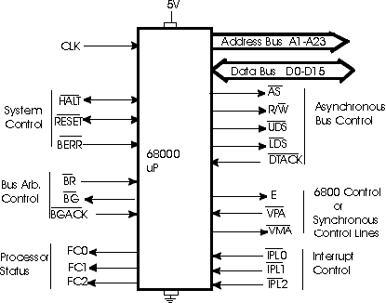

Address Bus:
The 68000 has an effective 24 bit address bus, but an actual 23 bit address bus (A1-A23). It uses two control lines to decode A0: UDS and LDS.
Data Bus:
The 68000 has a 16 bit Data Bus (D0-D15).
Control Bus:
The 68000 has many control lines, as shown in the diagram. Each Set of control lines will be discussed, with an emphasis placed on those control lines which will have the most significance in your project .

Asynchronous Control Lines
The Asynchronous Control Lines are shown below. They are:

Address Strobe - AS
Read/Write - R/W
Upper Data Strobe - UDS
Lower Data Strobe - LDS
& Data Transfer Acknowledge - DTACK

The 68000 uses these control lines when transferring data between itself and 68xxx peripherals. The sequence of events for a memory read is as follows :

 | 1 | The 68000 places an address on the Address Bus.
 | 2 | The R/W should already be high (default state)
 | 3 | The 68000 pulls AS low to indicate that there is a valid address on the Address Bus
 | 4 | The 68000 will pull UDS and/or LDS low depending on the data size and the
 |  | address being read.
 | 5 | The decoding circuits and memory ICs then go into action. When memory has been
 |  | enabled and the 68000 can complete its cycle, the decoding circuit must pull DTACK low. This input to the 68000 informs the microprocessor that it may now complete the read cycle.
Synchronous Control Lines
The Synchronous Control Lines (also known as the 6800 peripheral control lines) are shown to the right. They are:

Peripheral Clock - E
Valid Peripheral Address - VPA
Valid Memory Address - VMA

Officially, these three control lines are the Synchronous Control Lines; but, a data transfer to/from a 6800 peripheral cannot take place without AS, UDS, LDS and the R/W lines. The sequence of events that takes place when the 68000 is transferring data to/from a 6800 peripheral is as follows:

 | 1 | The 68000 places the address of the 6800 peripheral (i.e.; the 6821 PIA or 6850
 |  | ACIA) on the Address Bus.
 | 2 | The 68000 pulls AS low to indicate a valid address is on the Address Bus.
 | 3 | The R/W will go into its active state (1 for read, 0 for write).
 | 4 | UDS and/or LDS will become active depending on the peripheral device's address
 |  | and the size of the data being transferred.
 | 5 | The decoding circuitry will become active to select and enable the peripheral
 |  | device. The decoding circuitry will also pull VPA low to let the microprocessor know that it is trying to access a 6800 peripheral.
 | 6 | The 68000 responds by synchronizing the E clock with the system clock (the E
 |  | clock has a 40% duty cycle, and only one cycle for every ten cycles of the system clock).
 | 7 | When E is synchronized, the 68000 pulls VMA low to indicate it is ready to
 |  | transfer data. VMA should be used as an enable input to the peripheral device.
 | 8 | When E goes high, the data transfer will take place.
Interrupt Control Lines
The Interrupt Control Lines are inputs to the microprocessor and indicate an interrupt level. They can best be summarized by Table 1.
Table 1 - Interrupt Levels
IPL2 | IPL1 | IPL0 | Interrupt Level
1 | 1 | 1 | 0 - No Interrupts
1 | 1 | 0 | 1
1 | 0 | 1 | 2
1 | 0 | 0 | 3
0 | 1 | 1 | 4
0 | 1 | 0 | 5
0 | 0 | 1 | 6
0 | 0 | 0 | 7 - Highest Priority (NMI)
Function Code Outputs
The Function Code Outputs are outputs from the microprocessor and indicate the microprocessor's status. They can best be summarized by the table below.
Table 2 - Processor Status
FC2 | FC1 | FC0 | Cycle Type
0 | 0 | 0 | reserved
0 | 0 | 1 | user data
0 | 1 | 0 | user program
0 | 1 | 1 | reserved
1 | 0 | 0 | reserved
1 | 0 | 1 | supervisor data
1 | 1 | 0 | supervisor program
1 | 1 | 1 | Interrupt Acknowledge
Bus Arbitration Control Lines
The Bus Arbitration Control Lines are shown below. These control lines will allow another microprocessor or a DMA controller to take over the 68000's Data, Address, and Control busses. The requesting device, called a Bus Master, requests the use of

the 68000's busses by pulling BR low (Bus Request). The 68000 will then pull BG (Bus Grant) low to indicate that it will

release control of the busses at the completion of the current cycle. When the Bus Master is ready to take control it will assert BGACK (Bus Grant Acknowledge) as long as BG=0, AS=1 (the 68000 is not using the bus), DTACK=1 (no external devices are using the bus), and BGACK=1 (no other Bus Master is trying to use the bus).
The Bus Master can release control of the bus by releasing BR. When it completes its cycle it then releases BGACK, and the 68000 has control of the system busses again.
System Control Lines
The System Control Lines include BERR (Bus Error), RESET, and HALT. The BERR signal is used to inform the 68000 that an error occurred during execution of

the current bus cycle. If the HALT line is NOT low when this happens, the 68000 will execute an exception routine and terminate the current cycle. If HALT is asserted, the 68000 will attempt to rerun the failed cycle.
Both RESET and HALT are bidirectional signals. Therefore, special care must be taken in developing the circuits that are connected to these pins.
As inputs and after a power is applied to the circuit, both RESET and HALT must stay low for 100ms. This is to ensure that power has stabilized and results in a total processor reset. A total processor reset will cause the 68000 to load the supervisor stack pointer from vector 0 (Addresses $000000-$000003) and the program counter from vector 1 (Addresses $000004-$000007).

Vcc, Ground, and Clock
The only lines left are Vcc, Ground, and Clock.
The Clock has three requirements:

TTL-compatible waveform
50% Duty cycle
10ns rise and fall time (12Mhz versions and up require 5ns)

The 68000 requires approximately 300mA of current. This is a little high for one input pin, so there are two Vcc and two ground pins. Both pins in each set must be connected for proper operation.

Pin Diagram
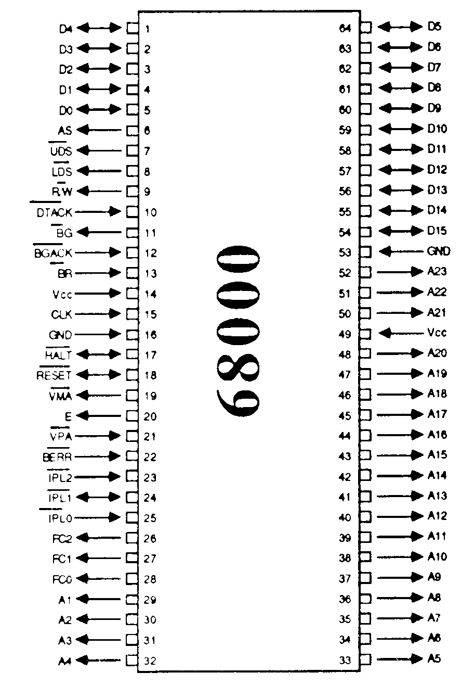

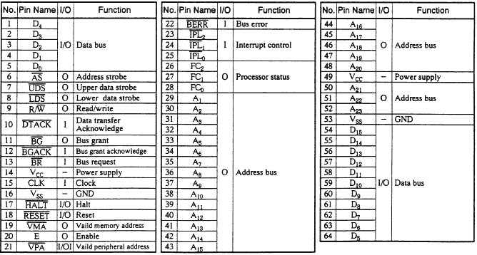
Addressing Modes
There are 12 modes in 68000 and 18 modes in 68020-68040.

1) Absolute Long
It specifies a 24/32 bit address directly. The data is read or written to that address.
Eg. MOVE.W$A56C20, D3 copies contents of address A56C20, A56C21 to D3.W
MOVE.W JUNK,D3 copies contents of address JUNK to D3.W
MOVE.W JUNK+2,D3 copies contents of address JUNK+2 and address JUNK+3 i.e. the same thing can be done with:
MOVE.W OTHER,D3
JUNK: DS.W1
OTHER: DS.W1
The last two examples are quite common with programmers but real assemblers always translate "absolute long" to a PC-relative mode. (relocability problems).

2) Absolute Short
It specifies a 16 bit address, sign extended to 24/32 bits. This gives addresses in 0000-7FFF lowest 32K memory and
FFFF8000-FFFFFFFF highest 32K memory. These areas often contain special system data which the operating system does not want wiped out. DoNOTuse.
Eg. MOVE.W $2F3C.W,D2
MOVE.W JUNK.W, D2
W refers to size of data W refers to size of address
If JUNK had address 0001A800 the effective address is FFFFA800.

3) Data Register Direct
It specifies a data register (i.e. D). Syntax Di
Eg. MOVE.W D3,D4 copies register D3 into register
D4

4) Address Register Direct
It specifies an address(A) register.
Eg. MOVE.L A3,D4
copies A3 into D4. Does not access memory.

5) Immediate
It specifies data that is embedded in the instruction. Syntax #value.
Eg.
MOVE.L #$A56C20,D3 copies $00A56C20 into D3
whereas
MOVE.L $A56C20,D3 copies contents of memory at A56C20 into D3

MOVE.W JUNK,D3 copies contents of memory at JUNK into D3
whereas
MOVE.W #JUNK,D3 copies address JUNK into D3
In a real system the last instruction would not be allowed due to relocatibility problems. It works fine on the Simulator but use
LEA JUNK,D3

6) 7) 8) Data Register Direct
It specifies the contents of memory at an address contained in an A register. Syntax
(Ai) or (Ai)+ or -(Ai)
(Ai)+ increments Ai by the size of DATA after using the address
-(Ai) decrements Ai by the size of DATA before using the address
Useful for stacks and arrays. You can get easy sequential access to data items in consecutive memory locations.
Eg.
Suppose A5 contains 00ABCDE0
Suppose memory is address content
ABCDDE 0000
ABCDE0 1234
ABCDE2 5678
then
MOVE.W (A5),D3 moves 1234 into D3.W
MOVE.W (A5)+,D4 moves 1234 into D4.W, then increments A5 by 2
MOVE.W (A5)+,D6 moves 5678 into D6.W, then increments A5 by 2
MOVE.W -(A5),D3 decrements A5 by 2, then moves 5678 into D3
MOVE.W -(A5),D4 decrements A5 by 2, then moves 1234 into D4
MOVE.W -(A5),D2 decrements A5 by 2, then moves 0000 into D2

9) Register Indirect with Displacement
It refers to contents of memory at address formed by adding a displacement to contents of An. Syntax: disp(An) or modern assemblers accept (disp,Ai). The displacement is a 16 bit 2's complement signed integer constant that is embedded in the instruction.
Eg.
If A3 contains $00ABC000 then
MOVE.W $0F3(A3),D3 will copy the word at address $00ABC0F3 into
D3.W
MOVE.L -1(A3),D1 will copy the long at address $00ABBFFF into D1.L
It is used for many data structures like structures and records. It is used for accessing portions of any block of memory whose location (first byte) is stored in a register. It is used a lot.

10) Address Register indirect with Index
disp(An,Rn) accesses the memory at (An+disp+Rn). Rn is the index and may be D or A register. Although complicated it is useful.

11) & 12) Program Counter Addressing Modes.
Not really used much by programmers but necessary for relocatability. More later.
Note that this gives access to memory + or - 32K from an address in An. This is the reason for many 32K byte limits on blocks of data. Eg. local variables in THINK Pascal.

Allowable modes
- Every instruction (opcode) will separately specify the addressing mode(s) which are allowed for its operands.
- Most instructions will accept most combinations of reasonable modes, but there are exceptions. (Example: for the "add" instruction one operand must be a D register, and the destination cannot be an A register.)
- An important point:
Only the above modes are allowed. All operands must have a syntax which EXACTLY matches one of these modes. The "Ai", "Di", and "const" values must be exactly that. They are not general-purpose "expressions" as used in high-level languages.
move.w 47(A3),D4 ;OK
move.w 47(D3),D3 ;no such mode - invalid
move.w D3(A3),D2 ;no such mode - invalid
move.w (A4+3),D1 ;no such mode - invalid
move.w 3+2(A4),D0 ;OK because "3+2" is still a "constant"

Instruction Set

